Map 1
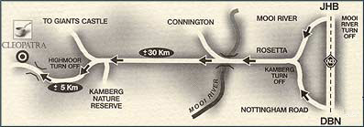
Map 2
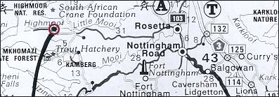
Click here to view a larger image of this map >>
GPS Co- Ordinates

DMS: Latitude: -29˚ 19' 28.099" DMS: Longitude: 29˚ 40' 16.996"
Decimal: Latitude: -29.324472 Decimal Longitude: 29.671388
- take the N3 to Durban
- take the very left hand lane at the MAIN Mooi River Toll (Mooi River South Greytown)
- turn right - back over the highway until T-junction (Engen garage and Wimpy ahead)
- turn left and join the R103. Travel 10km south to Rosetta
- At Rosetta turn right onto the Kamberg Road (opposite the Ugly Duckling)
- stay on the tar road for 30 km until you reach the Cleopatra, Dondini & Silver Hill sign (also Highmoor & Glengarry sign)
- turn left onto this dirt road
- travel for 5 km until you reach a single lane bridge
- approx 500m after the bridge the road turns sharply left to climb the mountain
- at this corner you will see a concrete wall with the sign "CLEOPATRA"
- ± 4 ½ hours travel time from Johannesburg
- follow signs out of the King Shaka Airport south bound towards Durban
- take the N3 to Johannesburg
- turn off at the Nottingham Road off ramp (exit 132)
- continue into Nottingham Road village (travel under the railway bridge)
- continue through Nottingham Road on the R103 north to Rosetta
- DO NOT TAKE THE KAMBERG ROAD AT NOTTINGHAM ROAD POLICE STATION
- at Rosetta turn to the left and follow the Kamberg Road (opposite the Ugly Duckling)
- stay on the tar road for 30 km until you reach the Cleopatra, Dondini & Silver Hill sign (also Highmoor & Glengarry sign)
- turn left onto this dirt road
- travel for 5 km until you reach a single lane bridge
- approx 500m after the bridge the road turns sharply left to climb the mountain
- at this corner you will see a concrete wall with the sign "CLEOPATRA"
- ± 2 ½ hours travel time from Durban

